**Introduction**

The word “brief” is in the title of Frederick M. O'Hara’s article, A Brief History of Technical Communication [1], however, there are a lot of redundant words and clauses which provide unnecessary context. O’Hara’s article also contains many technical words which are difficult to understand. For the average person, O’Hara’s article will be easier to understand with the revisioning of certain passages.

**Proposed Revisions**

A close up of a piece of paper

Description generated with high confidence

Fig. 1 [1] Original passage 1

The concept of “the social system of science” can be misinterpreted into associating science with irrelevant notions such as partying - especially if the reader does not have a scientific background. In addition to this, it is redundant to specify both “innovations and advances in science” because it means the same thing.

Proposed Revision 1: “The scientific communities’ dependence on technical communication has allowed for advances in science, medicine and technology.”

A close up of a piece of paper

Description generated with high confidence

Fig. 2 [1] Original passage 2

Stating that the “rapid change in technical communication has been obvious” in Fig. 2 is confusing as well as redundant because it does not address to who it has been obvious for.

Proposed revision 2**:** Advancement in technology has caused a rapid change in technical communication.

A close up of a logo

Description generated with high confidence

Fig. 3 [1] Original passage 3

Many readers do not understand what an apprenticeship is and the words “transmitted orally” in Fig. 3 can be easily misinterpreted into unrelated concepts such as viruses being transmitted around.

Proposed revision 3: Past knowledge of scientific observations and technological developments was recorded and passed on to younger generations.

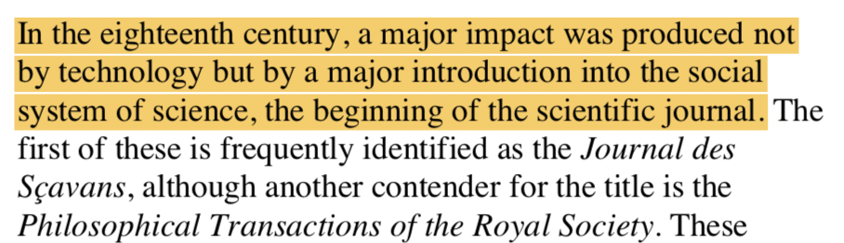

Fig.4 [1] Original passage 4

There are two cases of the word “major” in Fig. 4 which adds redundancy. In addition to this, the phrase “the beginning of the scientific journal” is confusing because it makes the scientific journal sound like an event that occurred and not an innovation.

Proposed revision 4: The start of the use of scientific journals in the eighteenth century had a major impact on the scientific community.

A close up of a logo

Description generated with high confidence

Fig.5 [1] Original passage 5

The word “periodicals” sounds too technical and can be replaced by magazines or newspapers which are more easily understood by readers. In addition to this, the word established should be removed because it confuses the idea of magazines and makes them sound like a business or establishment.

Proposed revision: Scientific societies used these journals to understand and comment on scientific observations.

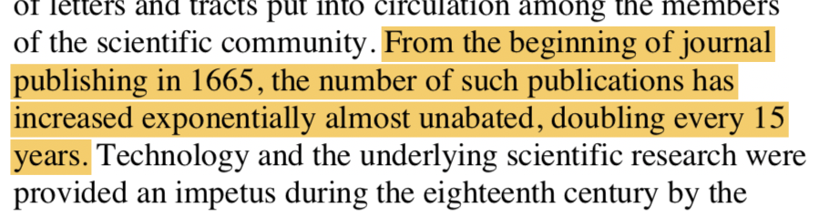

Fig. 6 [1] Original passage 6

The phrase “almost unabated” in Fig. 6 is redundant as well as “increased exponentially” because it is saying the same thing as “doubling every 15 years”.

Proposed revision: The number of journal publications increased exponentially since the start of journal publishing in 1665.

A close up of a logo

Description generated with high confidence

Fig. 7 [1] Original passage 7

The definition of the word “impetus” in Fig. 7 is confusing and should be removed because the patent system is not clearly defined.

Proposed revision: The introduction of the patent system in the eighteenth century motivated the scientific research associated with technology.

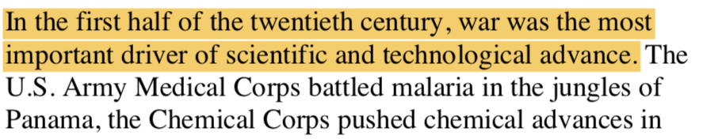

Fig. 8 [1] Original passage 8

Associating war with the word “driver” in Fig. 8 makes war sound as if it can drive automobiles. “[D]river” has a confusing meaning when used in this context and should be removed.

Proposed Revision: War was the most important cause of scientific and technological advance in the early twentieth century.

A close up of a logo

Description generated with high confidence

Fig. 9 [1] Original passage 9

The phrase “beneficiaries of belligerence” in Fig. 9 is too technical because the definition of the word “belligerence” is confusing. Belligerence means “warlike behavior” in this passage and should be changed to that so that the context can be more easily understood.

Proposed revision: The use of technical communication is a benefit in warlike behavior.

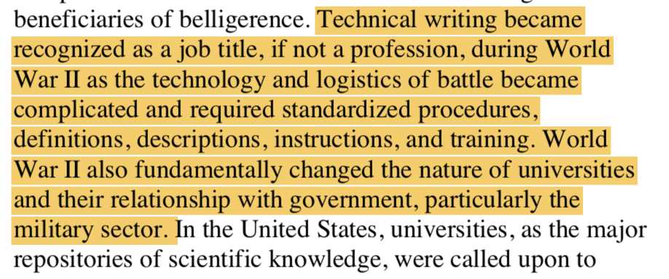

Fig. 10 [1] Original passage 10

It is redundant to list the requirements of battle because the subject is about technical writing and not about World War II. Also, the phrase “nature of universities” in Fig. 10 is confusing because it can be misinterpreted into associating things of nature such as trees and animals with universities.

Proposed revision: Technical writing became a profession because of World War II due to the complicated technology and logistics of battle. World War II also changed universities and their relationship with the government; particularly the military sector.

**Conclusion**

As it is now, O’Hara’s article is too difficult to understand. The modification of O’Hara’s original article with the aforementioned proposed revisions will supplement the article’s readability and allow it to be more easily understood by people who are interested in the history of technical communication without having prior knowledge in that subject.

**References**

[1] O’Hara, F. (2018). A Brief History of Technical Communication